**Digital Signal Processing Lab**

**Experiment 1: Generation of Basic Signal**

**Lab Output**

**Sine Wave**

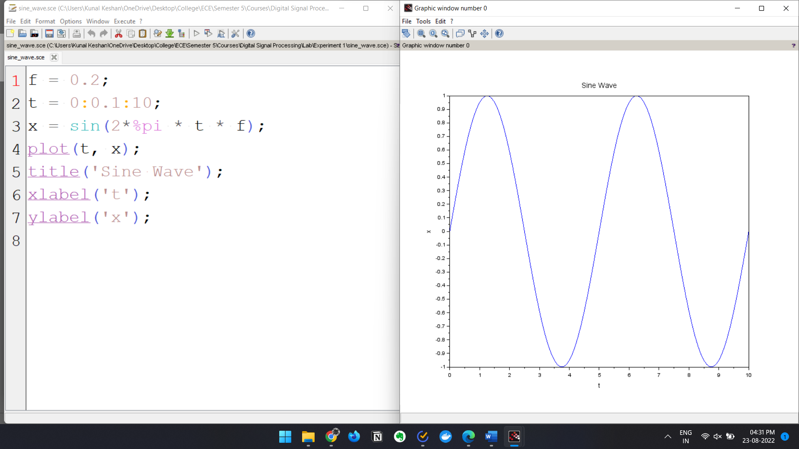

**Cosine Wave**

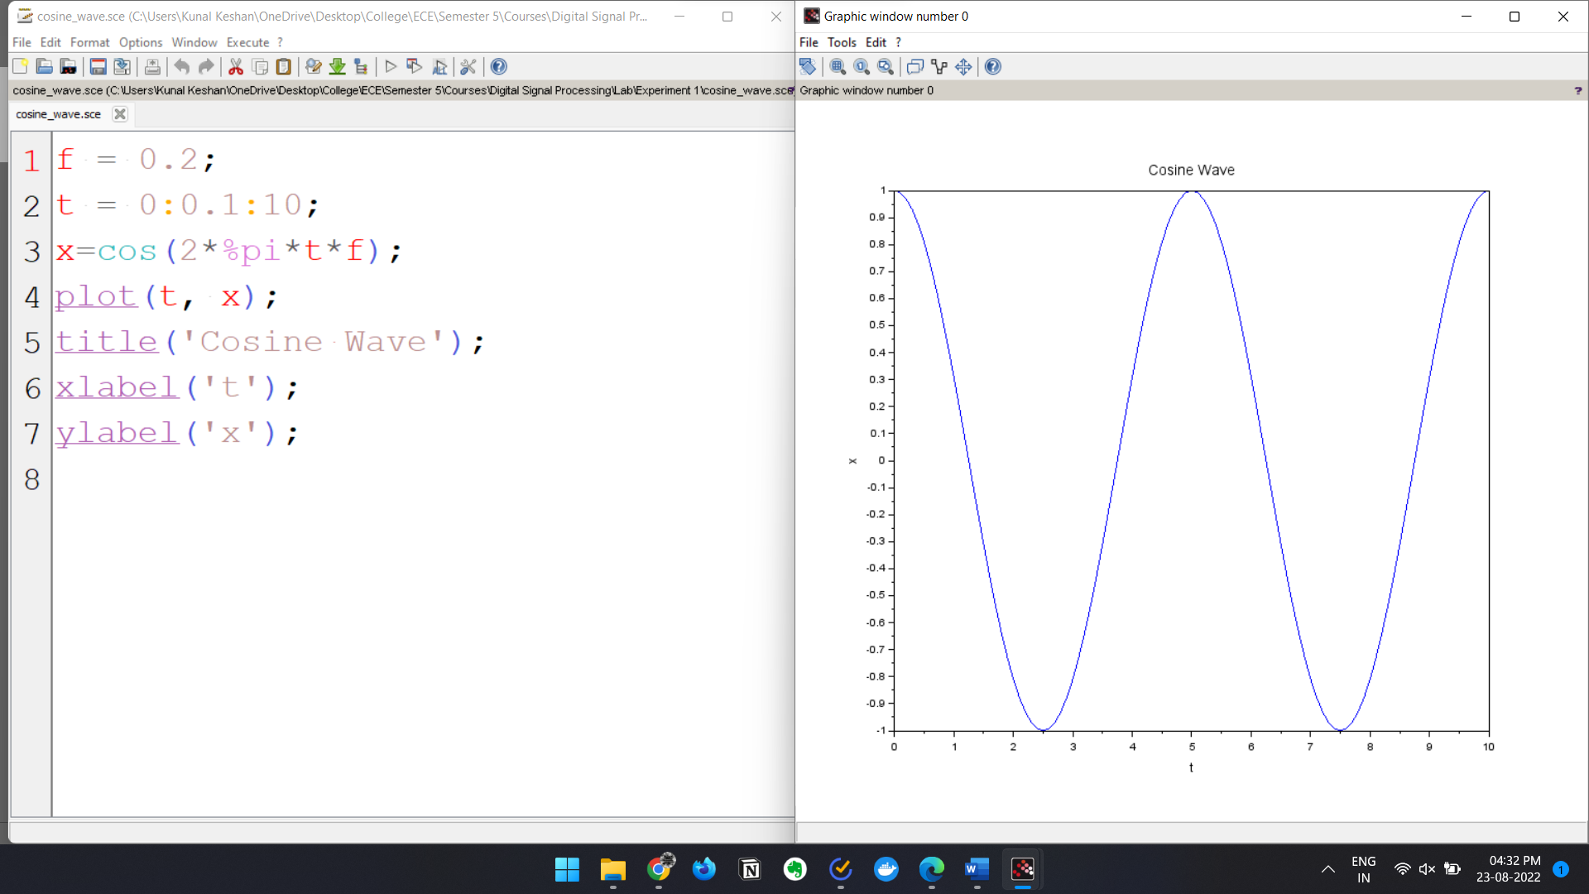

**Triangular Wave**

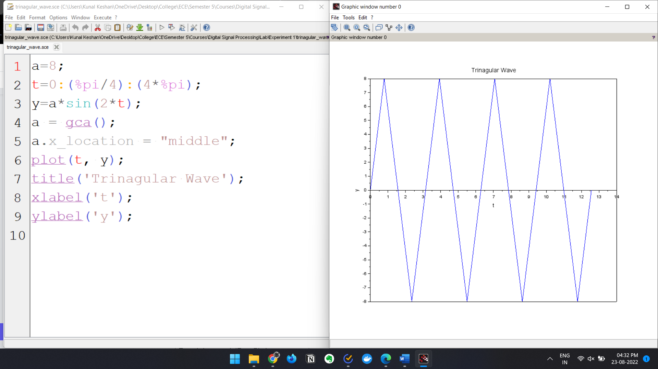

**Exponential Wave**

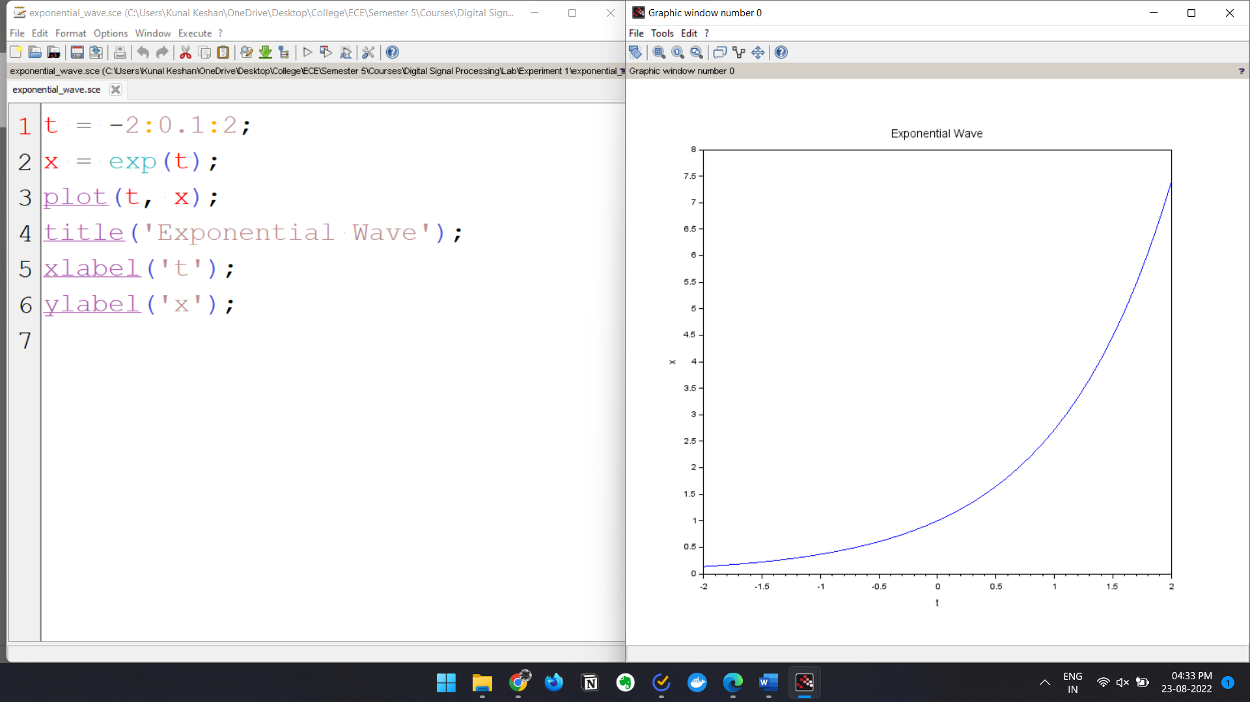

**Unit Impulse Signal**

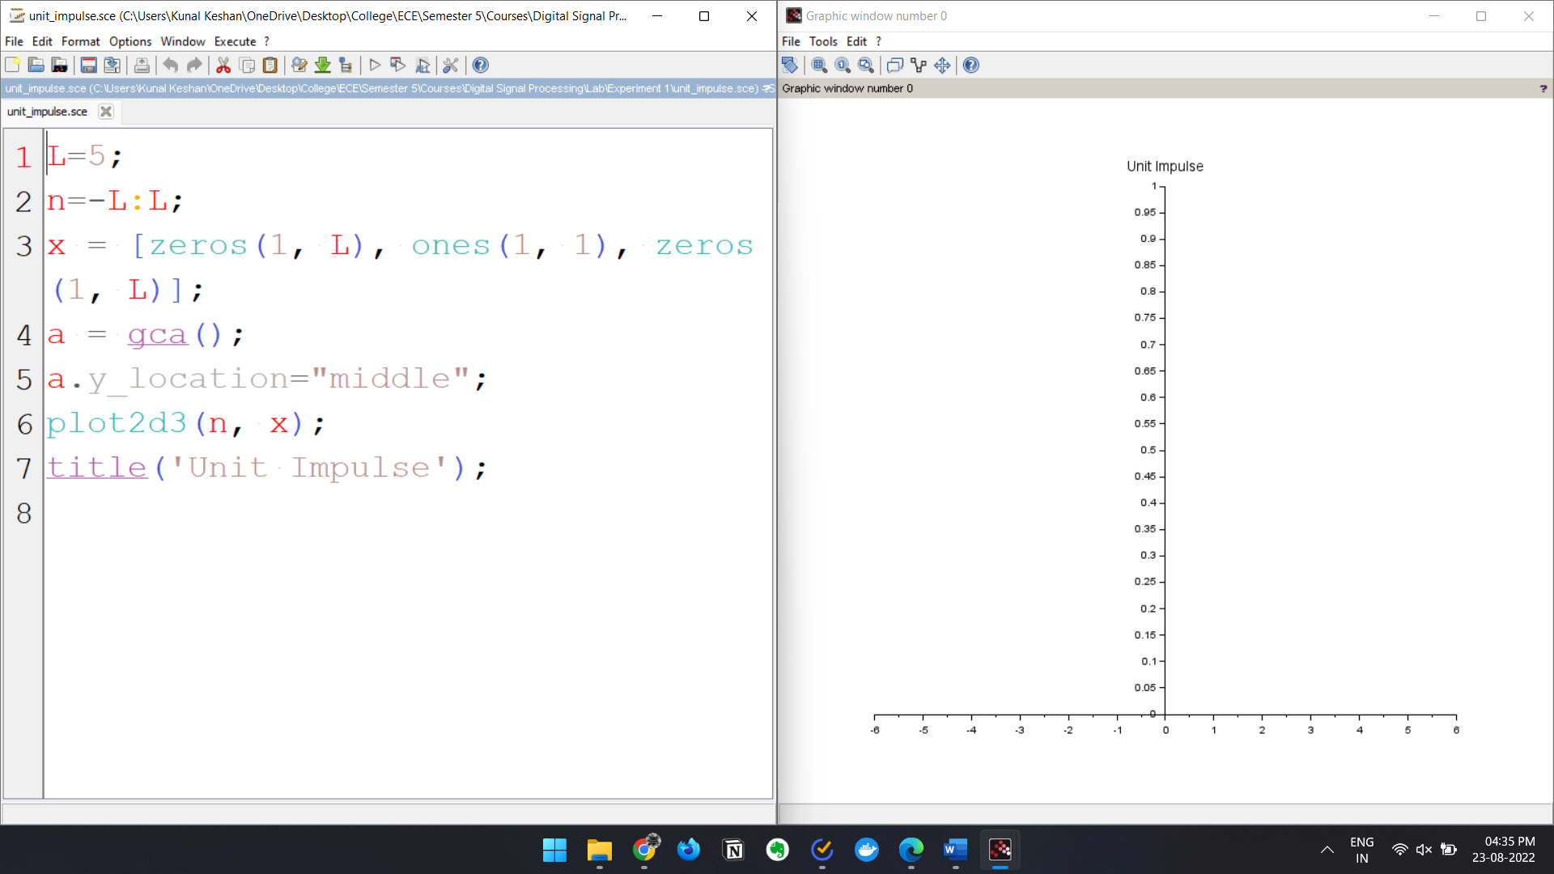

**Unit Step Signal**

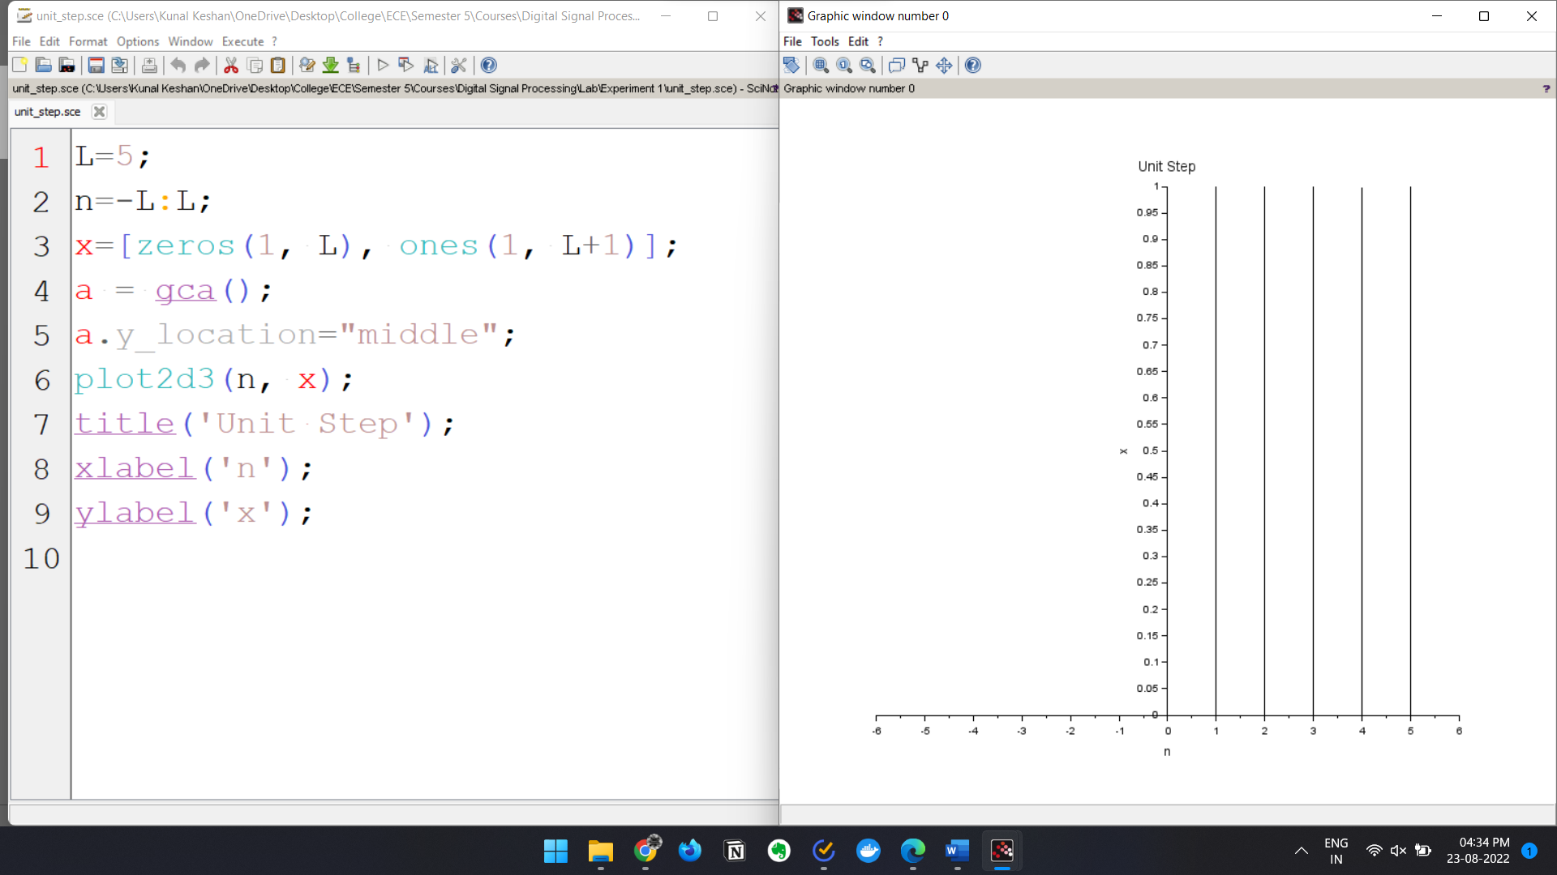

**Unit Ramp Signal**

